Git Repo: link
Screenshot:
1. The preview state, the rejected-file message, the avatar rendered on a fresh load.
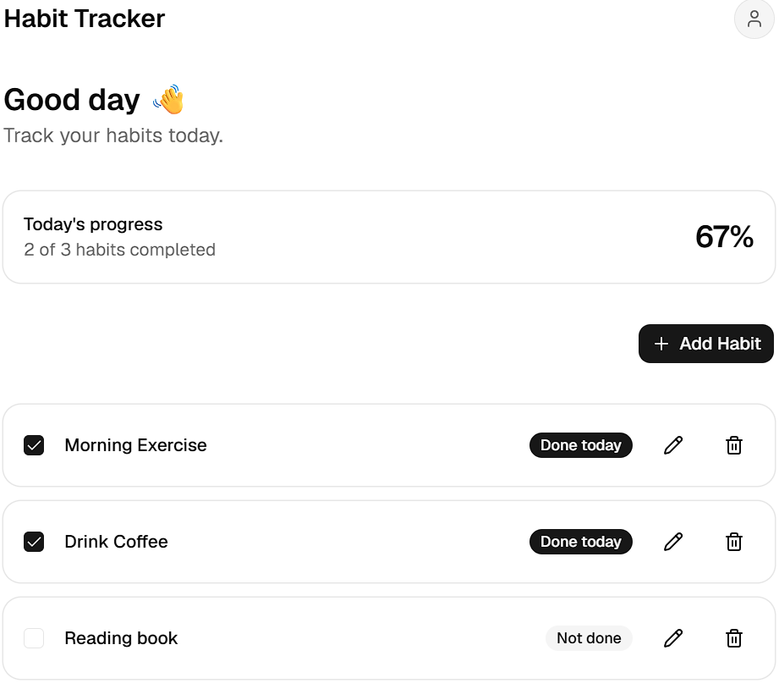
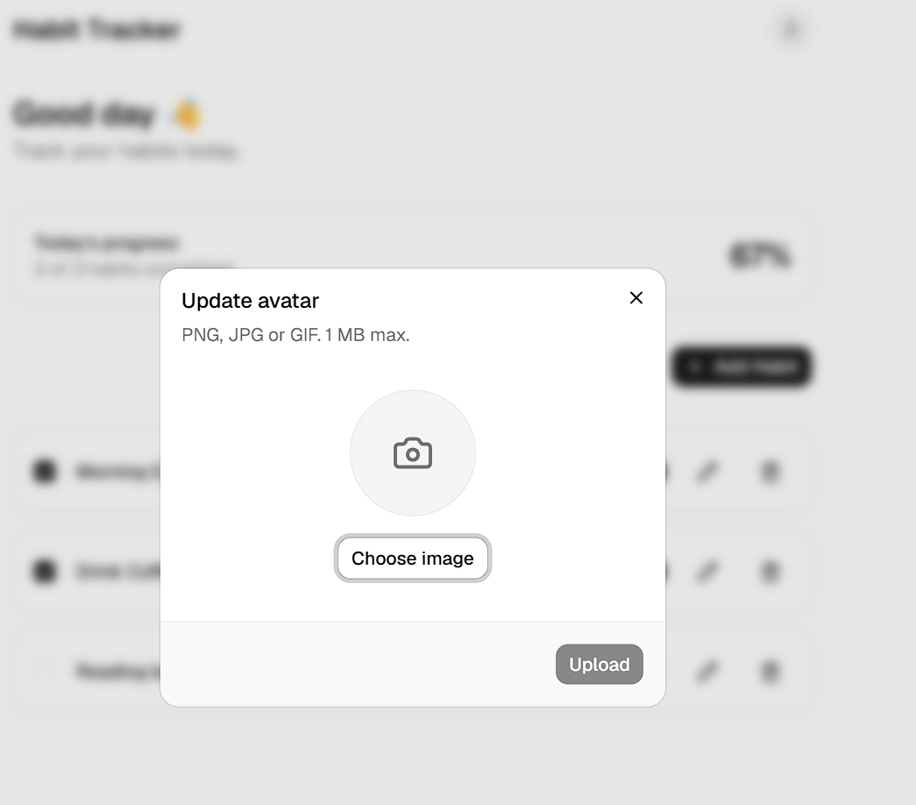
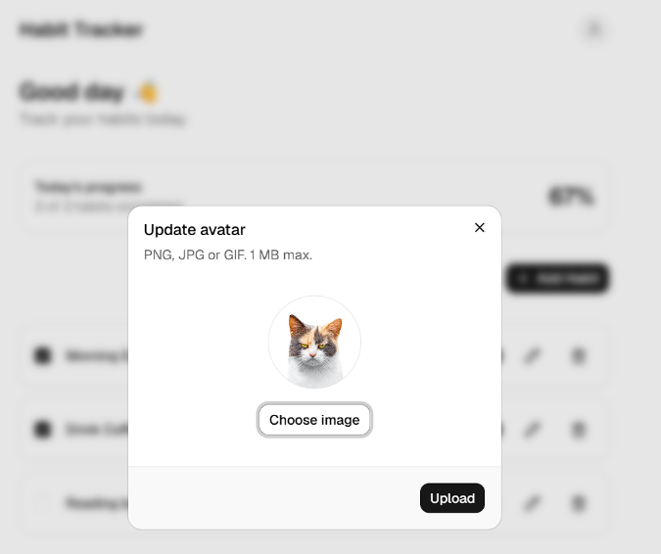
2. A screenshot of a boundary in action (temporarily throw in a child component) proving the rest of the page survived.
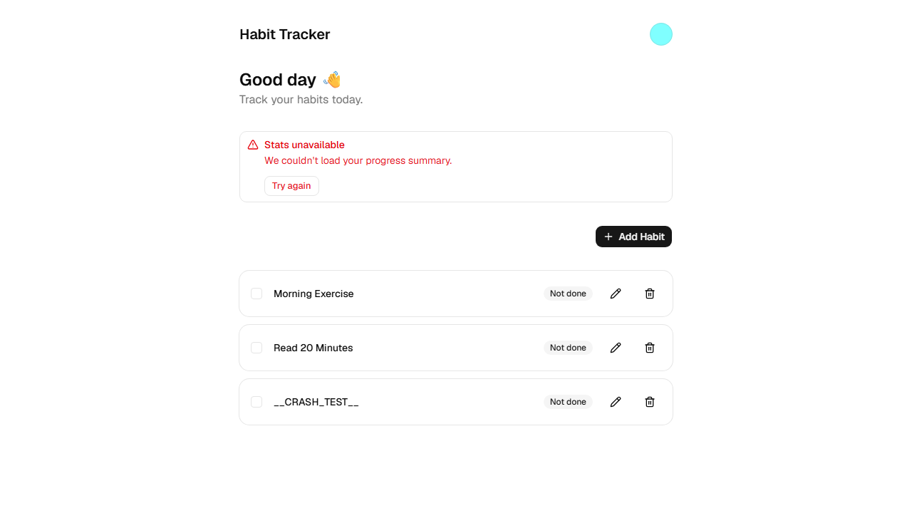
One sentence: why client-side validation is UX and the storage policy is the security.
Client-side validation is UX because it's just JavaScript running in the user's browser trivially bypassed by anyone calling the Supabase API directly; the storage RLS policy is the real security because it's enforced server-side on every request regardless of what client sent it.

